

May 2025

The monthly newsletter published by residents of  
Heritage on the Marina, San Francisco CA, USA

# Country of the Month

Yes, that is Frida Kahlo blowing on a traditional Mexican horn for our masthead cameo this month. And that must mean that our country of the month is Mexico, and our headline colors must be the colors of the flag: **red** and **green**.

# Special Dining Events

* May 5: Cinco de Mayo lunch with Mariachi Band
* May 9: May birthday night
* May 11: Mother’s Day lunch
* May 26: Memorial Day lunch BBQ

Look for the festive menus and Lisa’s napkin-folding artwork!

# New Staff: Archie

Archie Madden has come on board as our new maintenance technician. Many of us are already familiar with Archie because he was previously employed as our evening security guard.

# Tech Support with Carl

Along with the wonderful Tess, you can now get help with your pesky TV and misbehaving computer by getting in contact with Carl:

“I offer personalized one-on-one consultations for the residents of Heritage on the Marina, designed to effectively resolve IT issues while enhancing your technical skills through education.”

“I can be reached directly by email at cwashington@allcovered.com or by phone with voicemail at 415-792-6469.”

# Katie’s Writing Workshop

Katie will continue to help us explore storytelling and the qualities that make stories memorable. No experience necessary. Notebooks and pencils provided, but computers welcomed. May 5 and 19 at 10 am in Friendship Hall.

# March Madness

Our third annual March Madness Lottery was a generous success. ;-) The event organizer was the winner. Patrick is donating his copious winnings to the Employee Appreciation Fund. Yay!

## SF Planning Commission

On Thursday April 17, a group of residents, admins and consultants gathered at San Francisco City Hall for a joint meeting of the Planning Commission and Historic Preservation Commission. Several of us spoke in favor of the motions to approve certification of the Environmental Impact Report and Certificate of Appropriateness. Both motions were passed with the proviso for a meeting with the Architectural Review Committee. The Heritage on the Marina Strategic Plan is making progress.

## Historical Document Scans

Sabrina has scanned hundreds of pages of Heritage on the Marina minutes, ledgers and records going back to the early 1900s. The images will be collated and made available for ongoing research.

# Visit to SF Zen Center

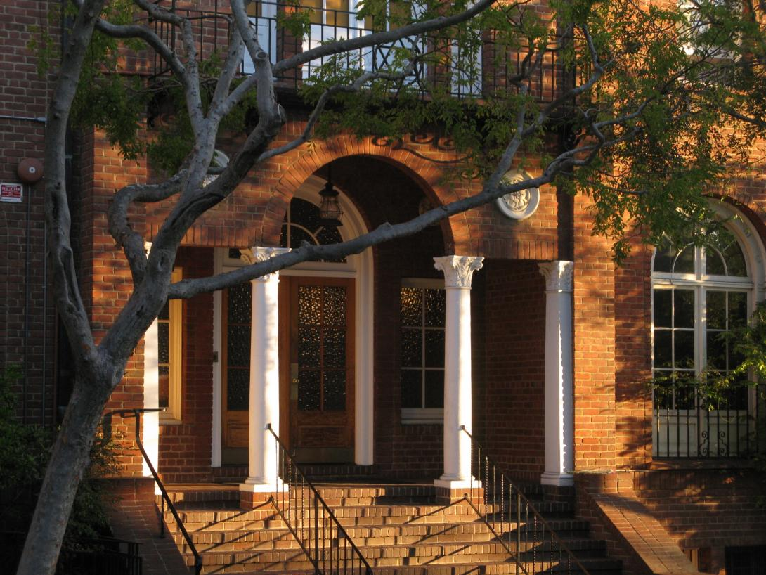In the 1920's Julia Morgan was commissioned to design a women's residence at the corner of Page and Laguna Streets. This stately building was purchased by San Francisco Zen Center in 1967 and sits at the opposite end of Laguna from its sister building, Heritage on the Marina.

On Tuesday, May 6 at 1:30 pm, the Out and About program offers a trip to tour Zen Center. June Fraps' cousin, author Laura Burges, a member of Zen Center, will lead the tour, along with Reverend Victoria Austin. Victoria, a Zen priest, trained as an architect and has studied the life and work of Julia Morgan.

We hope you can join us!

We will be joined at the Center by members of Next Village.

# March Madness

Our third annual March Madness Lottery was a generous success. The event organizer was the winner. Patrick is donating his copious winnings to the Employee Appreciation Fund

SF Planning Commission

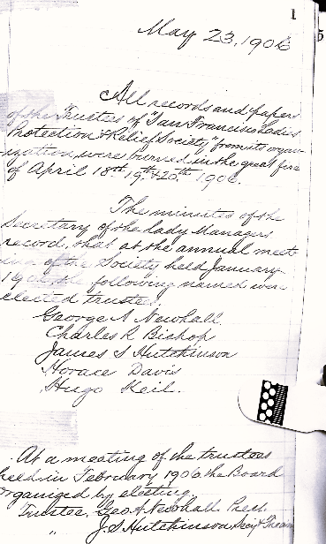

# Future Issues: *Heritage Happenings*

By Theo Armour

It’s time to rethink how I edit and publish *Heritage Happenings*. Although I don’t keep a timesheet, each issue easily demands forty-plus hours—much of it spent wrangling text and images into a print-friendly layout.

Print also limits what we can do. Paper pages can’t:

* Offer real interactivity—clicking, dragging, scrolling, filling forms
* Embed multimedia—audio clips, animations, live feeds
* Show real-time updates
* Personalize content to each reader
* Enable two-way engagement—comments, chats, purchases

So I’m shifting focus: *Heritage Happenings* will move primarily to an interactive online format, with print becoming a secondary, archival version.

The refocus enables me to develop skills and provide new services. Perhaps even publishing the *Heritage Happenings* not just as a web page, but also as an audiobook or video. What this means for the look and distribution of the paper copy is still to be determined.

# Leadership Updates

*Selected items from the April Leadership Meeting notes*

## Centennial Celebration of the Morgan Building

This event was not only a celebration, but a fund-raiser and a friend-raiser and it did both. We raised **$50,800**. We also gained important political support with San Francisco Board of Supervisors Sherrill and Mandelman, our State Assembly member Stefani, and Congress member Pelosi.

## Affiliation Update

Currently there are some communities that have shown interest, but there are no commitments at all. These communities are basically “kicking the tires” and getting a look at us, and we are getting a look at them.

## New Van

Our Board Director, Scott Hindes, has purchased a **new van** for us, using funds earned on our Out and About restricted endowment. It will arrive in early May.

## Medications Reminder

A doctor's order is required for **all** medications, including pain meds (Tylenol etc), supplements, etc, in order for a nurse to assist with administration.

*Heritage Happenings*  
The monthly publication published by residents of   
[Heritage on the Marina](https://heritageonthemarina.org/)

## Editor Emerita

Margaret Jacobs

## Editor

Theo Armour

## Associate Editor

Mia Cotton Harlock

## Editorial Committee

Jane Standing   
Martha Nell Beatty   
Doris Howard  
Tom King  
Margaret Missiaen

## Reporter at Large

Trish Otstott

## Proofreader

Midge Mansouri

## Website

[heritage-  
happenings.github.io](https://heritage-happenings.github.io)

## General Disclaimer

The views and opinions expressed in this publication are those of the authors and do not necessarily reflect the official policy or position of Heritage on the Marina.

© 2025 Heritage Happenings authors.

No rights reserved.



# Considering a Larger Family

As your editor—and fellow resident—I want to share some thoughts on our early exploration of joining a larger nonprofit network. This is not a decision taken lightly, and I know many of us feel protective of the close-knit, caring culture we’ve built here.

Still, there may be unexpected benefits worth considering.

We could gain access to richer programs, **more activities**, and enhanced wellness services. Our staff might receive **better training** and support, which strengthens the care we all receive. Operationally, a larger partner can offer **stability, resources, and expertise** that help secure our future without changing our identity.

Fingers crossed: We’re not losing our independence — we’re exploring ways to strengthen it.

I’ll continue to keep you informed as this unfolds. For now, I welcome your thoughts, questions, and concerns.

Let’s face the future as a community —open-minded, clear-eyed, and always looking out for each other.

* Theo Armour

# Letters to the Editor

By Val Szigeti

I was intrigued to read Fred Wentker’s article in the April issue entitled *The Population Bomb*.

Fred writes that “Population growth did continue until the turn of the last century. Then something unexpected happened. Growth stalled, and from then to now it has declined”.

I find the wording a bit confusing. The population of the world in 2000 was about 6 billion, and now it is 8 billion, so the population has not declined; it increased by 33%, just in 25 years, and it continues to increase each year by close to 1%. [https://www.worldometers.info/world-population/world-population-by-year/.](https://www.worldometers.info/world-population/world-population-by-year/)

The global fertility rate in 2024 was 2.2, above the 2.1 replacement level mentioned by Fred. Encouraging immigration from countries with higher fertility rates to those with lower fertility rates would be one solution. [https://www.un.org/development/desa/pd/sites/www.un.org.development.desa.pd/files/undesa_pd_2025_wfr-2024_advance-unedited.pdf#page9](https://www.un.org/development/desa/pd/sites/www.un.org.development.desa.pd/files/undesa_pd_2025_wfr-2024_advance-unedited.pdf%23page9)

A variety of policies intended to support families and balance family and work life are available. These include mandating employers to provide paid parental leave and flexible working arrangements, supporting affordable childcare and housing, ensuring the provision of comprehensive care for the older population, and encouraging an equal distribution of caregiving and household responsibilities between men and women.

~ ❧ ~

## Martha Nell’s Mother

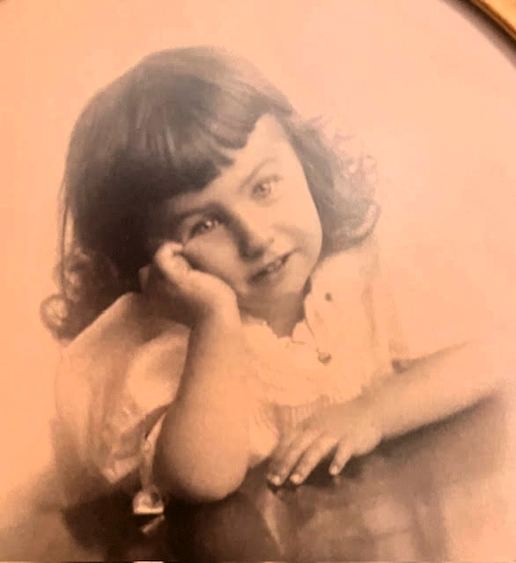

# Our Parents, Our Self

By Mia Cotton Harlock

By the time you reach a certain age, you know who we are, right? Or maybe you think we do. But take a moment: Can you hear your father’s voice in your reactions? Your mother’s sage (or scolding) advice in your decisions? Are your thoughts and behaviors uncannily similar to those of mom or dad? Or have you done your darndest to reject their path and carve out your own.

As part of our monthly *Heritage Happenings* health topic series, let’s to ask: how much of “you” traces back to the voices, values, and quirks of your parents — and their parents?

## Glass Half... What Exactly?

Were your parents optimists, radiating hope and silver linings — or were they weighed down with worry, stuck in a negative spiral? Did they fill you with warmth — or keep their distance emotionally? Did you feel seen, heard, and cherished — or like a guest in your own home?

## Life of the Party — or a Quiet Corner

Did your parents host dinner parties with relish — or hide when the doorbell rang? Were they energized by interaction or depleted by it? Their social nature (or lack thereof) may have quietly laid tracks for your own. Are you more like dad or mom in the social department? When a room fills up, do you lean in — or step back quietly?

## Doing for Others

Did mom or dad serve soup to the poor or spearhead the annual fundraiser? Were they civic-minded — or more focused on family? Do you feel their example shaped your own sense of service?

## Understanding vs Arguing

Were debates around the dinner table productive or exhausting? Was one parent diplomatic while the other held firm in their views? Do you now avoid arguments like the plague or feel compelled to win them? How might their tone and temperament still echo in your interactions?

## Roots of Roots

Were your parents’ parents proud immigrants, tough-as-nails survivors, or gentle nurturers? How might their legacy live on in you? Were your grandparents steady fixtures in your life — or distant figures in dusty photo albums? Have you considered how their experience and influence filtered through your parents on to you?

## Parenting the Next Generation

Ah, the joys (and chaos) of raising kids — or grandkids, or even grand-dogs these days. When you think back, did you parent the way your folks did or toss their rulebook out the window? Were you more of a “because I said so” or “let’s talk it through” kind of parent? Can you spot family habits that stuck? Or bold moves you’ve consciously made to parent (or grandparent) differently?

## Full Circle

As you sit in, say, the Julia Morgan Building opened in 1925, contemplating your parents, their parents, and possibly your own children and grandchildren (if you have them) — it’s a trip to see how the past tags along, or not, depending on how you steered your life.

But one thing is undeniable: Whether we’ve embraced or rejected our parent’s teachings, behaviors, and ways of being — we carry them with us into our “I” of this very moment. So here we are — part inheritance, part invention, still figuring it out

# Gender Neutral Pronouns

By Val Szigeti

There are a few languages that do not differentiate between he and she. People using these languages do not have to invent new ways of addressing this divisive issue, like using they, in order to slide into the 21st century. Really, guys and girls (hmmm?), “they” is plural.

Some languages that use a single pronoun for he and she are Hungarian, Finnish, and Turkish. Mandarin Chinese is unique in that there is a difference in the written symbols for he and she, but there is no distinction in pronunciation.

I am fascinated by languages! I am most familiar with Hungarian; the word for he or she is ő. The question to ask is does the gender-neutral pronoun imply less gender discrimination? In Hungarian, apparently not. The word for kindergarten teacher in Hungarian is *óvónő*, which, translated into English, is protective (*ovó*) lady (*nő*). Also, there are two different words for secretary. *Titkár* is used to cover the case of the Secretary of State, for example, while *titkárnő* (you now know that *nő* is lady) is used for the woman who takes dictation for and brings coffee to the Secretary of State.

# Alex Creasy ~ Dining Room Manager

By Martha Nell Beatty

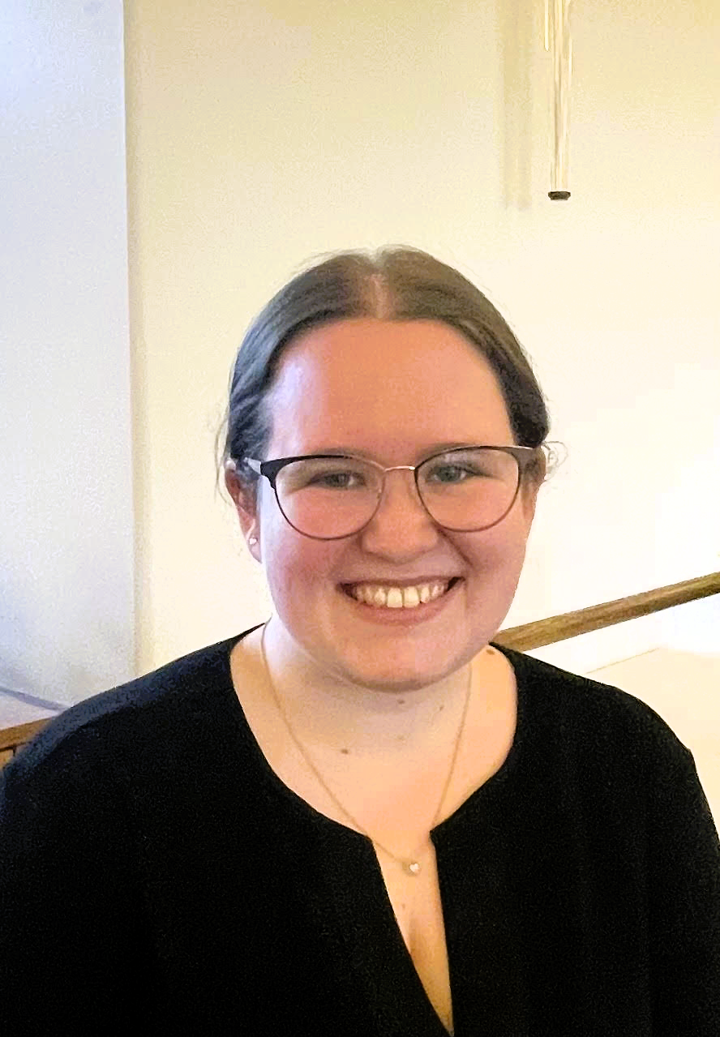

Alex grew up in Elk Grove, just south of Sacramento and left the area at 17 to go to college. Early on she showed an interest in the culinary world and was into dessert and baking. She baked with her grandmother, who was famous for her peanut butter cookies. Alex would watch champion baking shows on TV. When Alex was older, she started to do a lot of cake decorating. She enjoyed making flowers out of gum paste, all the intricate details.

When it was time for college, Alex told her father that she wanted to go to culinary school and become a baker. His response was that she needed to attend a real college. And so, she did — and was accepted to San Francisco State as an accounting major. After a couple of years, Alex was still interested in the culinary field. When she talked to her counselor, Alex found out that most of the pre-recs she’d taken for accounting, like statistics and economics, were the same ones needed for hospitality. Alex made an easy switch to becoming a Hospitality and Tourism Management major.

Alex’s last two semesters coincided with the arrival of Covid. No more in-person classes. She missed out on her wine class and working in a kitchen for hands-on experience. Graduation was remote. Since the hospitality field was dead at the time, after her graduation, Alex moved to live with her mother in Lodi. Her first job was with Farmers Insurance as an executive assistant. She worked remotely except once a week, when she drove an hour to Pleasanton.

Alex decided to move back to San Francisco, still working for Farmers. After a year, she was able to move into the hospitality field with a job at Bon Appetit, which—like Morrison—is a Compass company. She worked as a Catering Captain at Uber Headquarters for over a year. They would cater meals for the board and social events for employees. Every few months there would be special events like Oktoberfest and a Farmers’ Market.

Alex left Compass and ended up working for another catering company called Betty Zlatchin Catering, where she was staffing manager for events. Sometimes they would have 100 staff, including servers and kitchen staff. The company averaged 10-12 events a week.

Alex wanted to get back to a Compass company and found the position of Dining Room Manager with Heritage on the Marina last June. One of her responsibilities is ensuring a smooth and enjoyable dining experience for residents and working closely with servers to improve the quality of service. Alex also creates seasonal menus for holidays and special events.

Alex commutes from and to Menlo Park, where her cat awaits her. She is trying to find time to work on her back yard. And, of course, she is still passionate about baking.

# My Mother

By Margaret Johnson

My Mother died when I was fifteen, so I never had a chance to know her as a grown-up.

Most of my memories of her are fond. She was quiet, as was my father, well-liked. My aunt, who was acquainted with her but not close, told me after she died, that occasionally, when going about their household chores, they would meet on the street and exchange a few words. “I always felt something lovely had just happened,” she said.

Mother scolded me gently, always. I remember when I had used up almost whole box of Kleenex to make a bed for my doll. That was the middle of the Depression and the box was too valuable to use as a toy. But there was never any physical punishment.

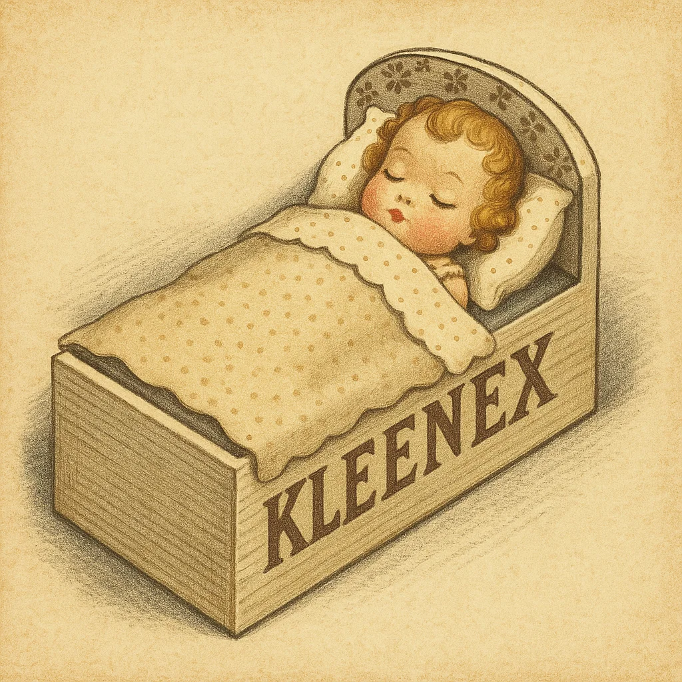

# *Via con Dios*, My Darlin

By Tucker Ingham

Surely, we all remember those delightful words played and sung so well by Les Paul and Mary Ford. "*Via Con Dios*, my darlin'" Go with God, my sweetheart, go with me into eternity.

Then there was the preppy Tijuana Brass with Herb Alpert's joyful trumpets accompanied by cheering crowds at the bullfight, a mariachi celebration. One didn't have to even cross the border; Mexico was already here. As the Kingston Trio said, "You want green peppers? I'll give you green peppers, Gringo, unless you are in a Tijuana jail and ain't got no bail."

So, fifty years ago, Charmly and I, newly arrived in San Francisco, took it upon ourselves to sign up for a ten-day spring vacation to Old Mexico, to experience enchantment firsthand.

First stop, Acapulco. Wow, those young men really did dive off some very high cliffs alright, down, down, down into the foaming sea below. But we had to put on our suits and run down to the golden sandy beach. The water was warm, the beggars not plentiful, no surf, just relaxing. After dinner we returned to our room, noticing the smell of sewage emanating from the bathroom where our suits were drying. Must have been some sewer pipes on the beach, explaining the lack of swimmers.

Also, in Acapulco not far away was a colleague of ours with his wife. They returned with paratyphoid. Maybe they drank the water. We did not. So, if you're going down to Old Mexico, think twice and *via con Dios.*



# Road Racing in Mexico

by Tom King

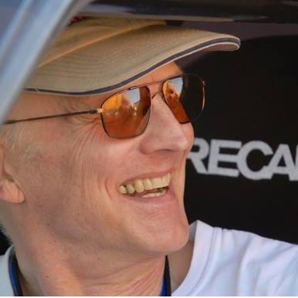

## Averting Disaster

Cresting the hill at 100 mph, we burst upon a family in the middle of the road: mother, father, two small kids and a puppy in the left lane, a larger dog in the right lane, and Meme and I in the Silkrip NSX tearing down the middle. Racing in Mexico means your day can go from good to very bad in an instant.

Immediate threshold braking, don’t lose control of the car sideways and collect them all, favor the right and hit the big dog if she moves, just trim her nose whiskers if she doesn’t. Give the family the most room possible. Please, nobody move!

With the weight all on the front tires, scrubbing off speed, we slid past as they were frozen in place, mouths agape. Check mirrors, everyone okay, our stage time ruined but not our lives. It was pretty quiet in the car. We knew how close to disaster we had been.

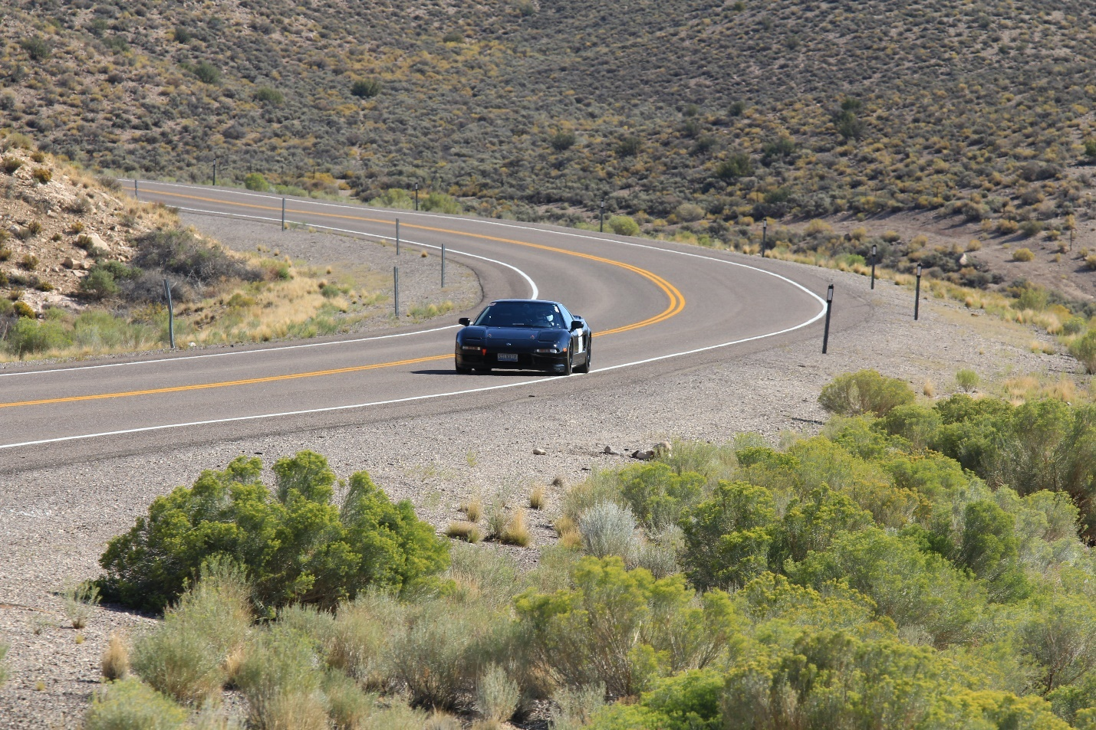

Racing in Mexico is dangerous, and we accept that for ourselves, but this was the most serious peril I had encountered for innocent bystanders. They were probably spectating in the woods as the cars sped by at one-minute intervals when the big dog wandered into the road. I imagine them venturing tentatively into the road to call the dog back, and then their worst nightmare suddenly hurtled toward them. I hope they eventually got over feeling like quarks in a Large Hadron Collider.



# Gray Kitty and Fancy: Two Cats in Quarantine

By Pam Bledsoe

In July of 1982, Bob & Pam & their two cats, Gray Kitty and Fancy, began one of several adventures. We were moving to Kailua-Kona Hawaii from San Francisco.

In those days taking animals to Hawaii was not an easy or cheap proposition. The state of Hawaii required a 4-month quarantine on Oahu. We were going to be living on the Big Island of Hawaii.

Fortunately, we had friends who had gone before & gave us tips on how to do this.

First tip – get a surrogate on Oahu. We found Susie. She visited the kitties 2 to 3 times a week at the quarantine station. When she visited, she could put the girls in the same cage where she would brush them, take them treats, & otherwise give them human companionship. After visits, the girls would dictate letters to us through Susie. Oh, did I mention that Susie smoked *Poko LoLo* (marijuana)? These were some of the funniest & strangest letters we ever saw – wish I had saved them.

Second tip – We visited the girls once or twice a month making a long weekend of the visit exploring Honolulu. We always found their habitat to be immaculate.

Finally, their incarceration was over, and they were flown to Kona.

The second day they were home; we tlrew a Debutante Coming Out Party. We ordered the girls their own leis, & they had their own special buffet. They knew this party was for them – they pranced around all afternoon entertaining our guests. One of our guests brought a magnum bottle of local wild catnip. It was labeled *Gato Ariba*. The girls loved it!

We also had a grown-up buffet & ample libations for our guests. Finally, a good time was had by all.

*This article was intended for the April* Heritage Happenings*. It just stayed in quarantine a bit longer.*

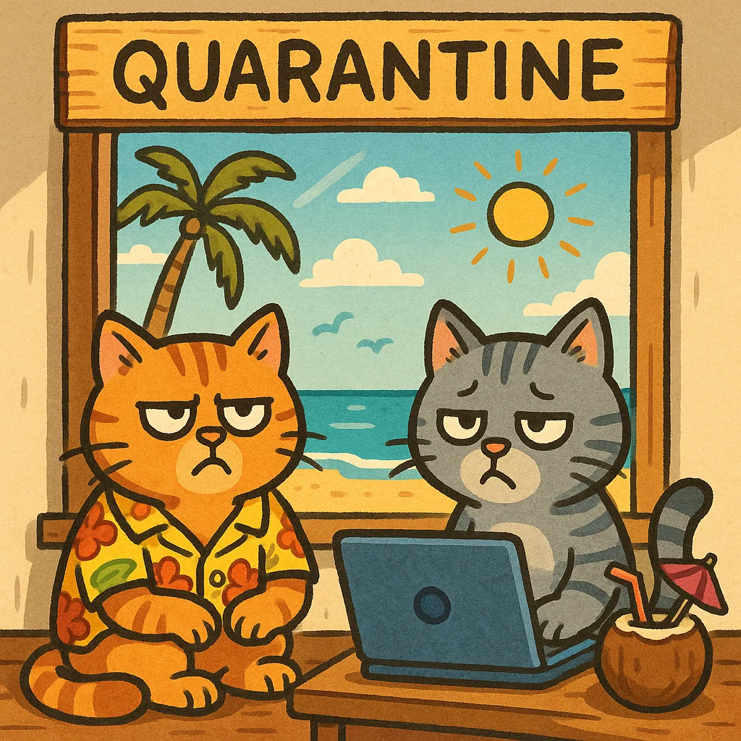

# *Alcatraz: The Last Escape*

by Ken Widner   
~ nephew of the Anglin brothers

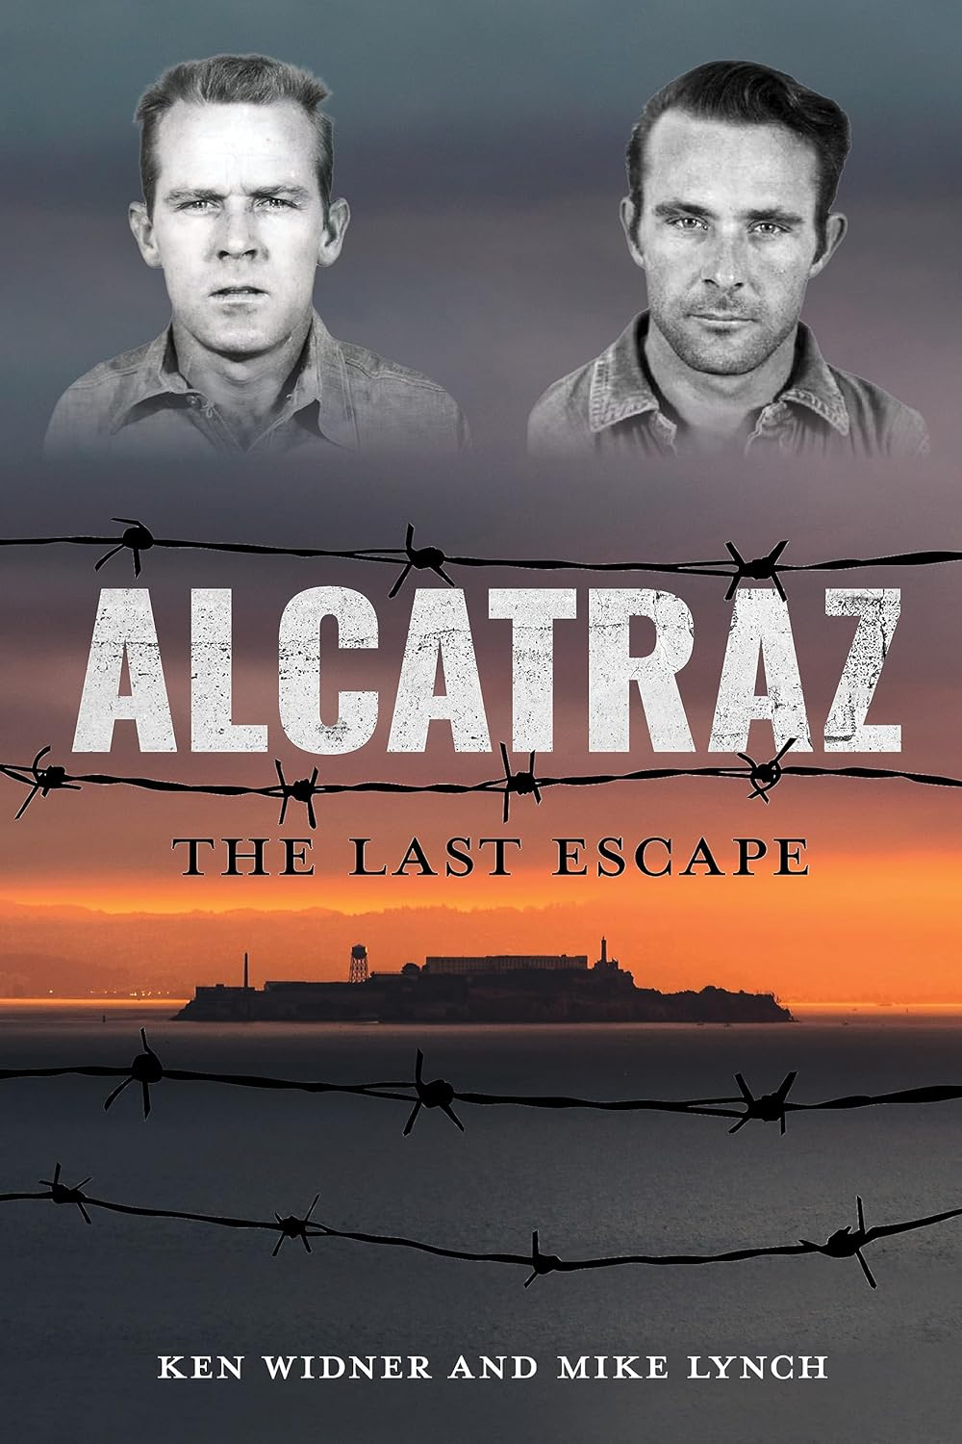

We have all traveled out to Alcatraz Island to see the remains of the Federal penitentiary, the remnants of the occupation by American Indians, and to enjoy the overall extraordinary views of the Bay and the Golden Gate Bridge. While touring the prison building, we all have heard the tale of the three prisoners who got off The Rock. What we do not learn is the fate of these three desperate men.

Frank Morris, John Anglin, and Clarence Anglin were the three prisoners who escaped from Alcatraz in 1962. Did they really make it?

*Alcatraz: The Last Escape* reveals the hour-by-hour details of their incredibly daring escape. You will read about the long months of planning, their ingenious gathering of supplies and, of course, their mustering of support from other inmates. Did you know there was a fourth prisoner also planning to escape that same night? Allen West’s chipping away at the wall of his cell was incomplete. He was not able to chisel the escape opening large enough to fit his body, so he was left behind. Other prisoners heard him sobbing hysterically late that night.

Did the three get away? Is the photo of the Anglin brothers (living in Brazil) the real deal? Was this famous escape facilitated by gangsters Whitey Bolger or Mickey Cohen? After you read this book, you can come to your own conclusions.

I recommend this book to anyone who enjoys local history and/or a thrilling read.

This is an excellent book for gifting.

Review by Trish Otstott

*This book is not in Stucky Library*

# Library Tips

Donating a book: there is a box for donating books. As we have limited space on our shelves, please don’t donate paperbacks.

Please don’t put catalogs or magazines on the Library table. We try not to have clutter.

# Clay Art by Jennifer Arthur

 